* **Instruction guide**

1.Download the zip to your desktop and unzip it;

2. Open ArcGIS pro and add the Dune Extraction test folder in Catalog - Folders;

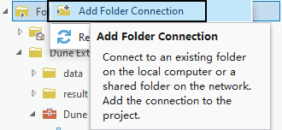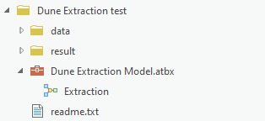

3. Open the Dune Extraction Model.atbx file, right-click the model Extraction, and click Edit;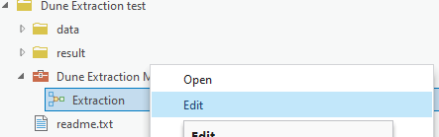

4. The model has two parts: Slope Cost Distance Calculation group and Post-processing group;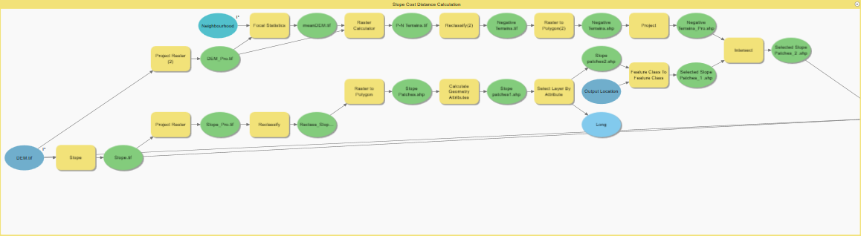

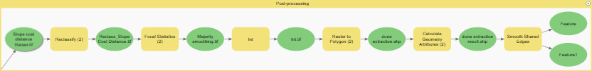

5. Model input includes: DEM data (in the Dune Extraction test/data folder), neighborhood size, and slope cost distance threshold;

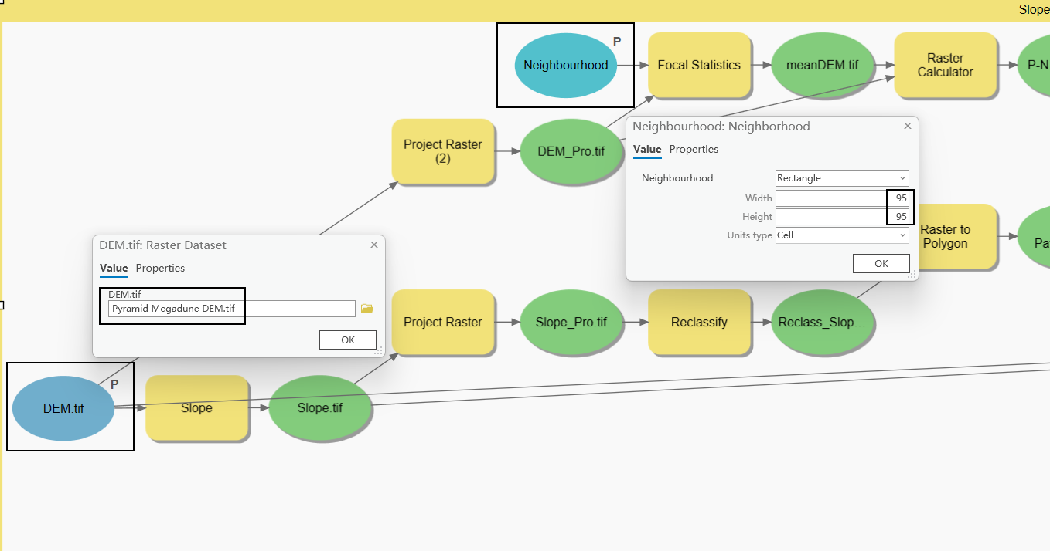

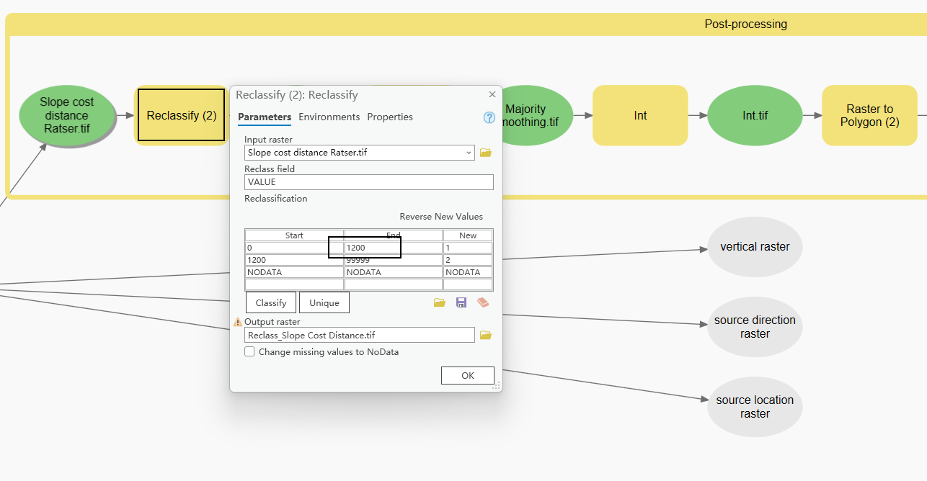

6. The intermediate data is located in the Dune Extraction test/data/mid data folder. The result data is located in the Dune Extraction test/result folder.

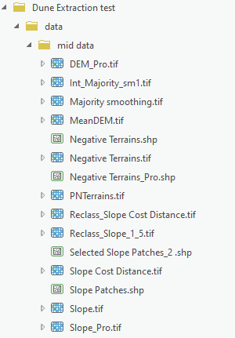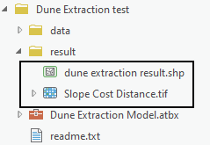

* **Detailed model explanation**

1. Slope Cost Distance Calculation Group

|  |  |  |
| --- | --- | --- |
| Tools | Function | Usage |
| Slope | Calculate slope raster based on DEM data; |  |
| Project Raster | Project DEM and slope rasters; |  |
| Focal Statistics | Set the Statistics type to mean and set the window size, which can be used to calculate the mean DEM; |  |
| Raster Calculator | Subtract the mean DEM data from the DEM data to obtain positive and negative terrain raster data; |  |
| Reclassify | Divide the positive and negative terrain raster according to the threshold of 0, and extract the negative terrain raster; |  |
| Reclassify | Divide the slope raster according to the threshold of 1.5° to filter slope patches; |  |
| Raster to Polygon | Convert raster data to vector data, here it is used to convert slope raster and negative terrain raster into slope patches and negative terrain vector data. |  |
| Calculate Geometry Attributes | Calculate the area of slope patches; |  |
| Select Layer By Attribute | Screen out slope patches with an area greater than 0.01 ${km}^{2}$; |  |
| Intersect | The intersection of two vector surfaces is obtained, and the intersection data is obtained. This is used to filter out slope patches located in negative terrain; |  |
| Distance Accumulation | Calculate the slope cost distance raster data using slope patches as the source raster, slope raster data as the cost raster, and DEM data as the surface raster; |  |

1. Post-processing Group

|  |  |  |
| --- | --- | --- |
| Tools | Function | Usage |
| Reclassify | Divide the slope cost distance raster according to the set threshold to distinguish dunes and interdunes; |  |
| Focal Statistics | Set the data type to Majority and perform mode smoothing on the raster data in the previous step; |  |
| Raster to Polygon | Convert the above raster into vector data; |  |
| Smooth Shared Edges | Smooth dune boundaries. |  |